CALL FOR TENDER ACTED Regional Office

Instructions to Bidders

Date: 8-July-2024

Tender N°: T/17FWC/WHG/IWK/Gaziantep/08-07-2024/1

Subject: Supplying of Kitchen Set to Hatay
Through this tender package, ACTED is requesting a qualified supplier to submit their proposal for the Supplying of Kitchen Set to Opet Camp, Kirikhan – Hatay.
Technical Specifications:

Simple Description | Detailed Technical Specification (English) | Unit | Quantity | Illustrative Image
Sink | The sink  The stainless steel sink is hygienic, durable, and long-lasting; at the same time, it is also easy to clean.  The steel part (sink) is made of AISI-304 (18/8-10) quality stainless steel sheet.  The product must have a shelf within the product itself located benath the sink  Provided by hangers as shown in attached images.  Dimensions: 112 (Length) x56 (Depth) x139(Hight) cm (Legs: circular or square profile, hollow with minimum thickness of 2 mm )  Built-in drainboard  Clean Water  20 mm PPrc pipe PN20 (1.5 meter) for clean water  Grey Water  Providing and Installing Ø 50 mm (diameter) x 1000 mm (the length) PVC Waste Water Pipe with the thickness of 3.2 mm Duplex (3 x 1000mm required)  Shipment and Installment  Shipment and Installment | Set | 405 | 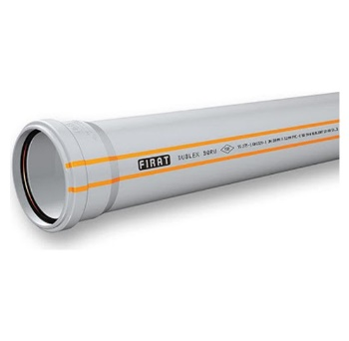  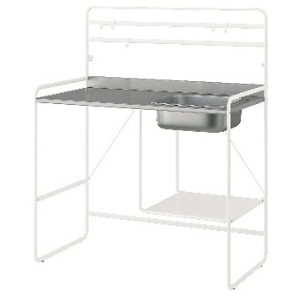  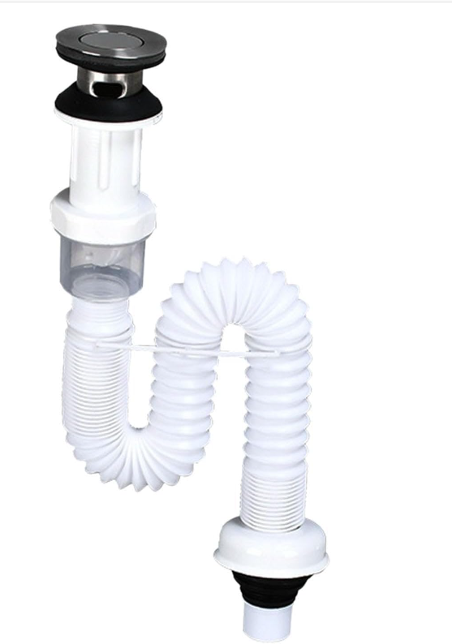
Kitchen Cabinet | It has 1 door, 2 drawers, and 4 shelves.  It is a versatile product that can be used as a coffee corner in the kitchen, a towel stand in the bathroom, an accessory stand in the living room, and as an organizer.  It is shipped in a first-quality double box.  Min Dimensions: 70(length)x33(Depth)x80(Hight) CM  Material: White Wooden MDF with covering and isolation with minimum 12-mm thickness (The wood should be pretected from water or any other harmful material)  Shipment and installing are Included | Pc | 405 | 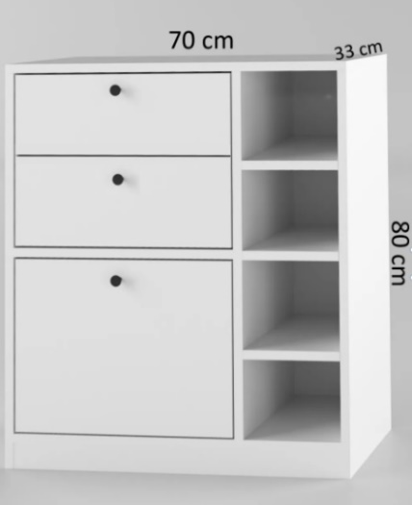
Tap | The Tap should be built-in and integrated into the sink in a way that makes it function.  In inlet of the sink : 1/2"  Material: Brass body, high-quality chrome plating  Movement: 360° swivel spout with flexible head  Water Inlet: Dual water inlet (hot and cold)  Additional Features:  Stainless steel connection hoses  Stainless steel mounting kit  High-quality, corrosion-resistant screws  All water and pressure tests successfully completed  Ready to use  Shipment and installing are Included | Piece | 405 | 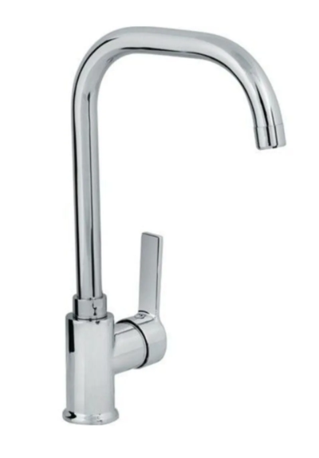

Responsibilities of the Supplier:

To submit a Proposal that includes all required elements and submittals as listed in PRO-06.3 BIDDERS CHECKLIST_v2.0_FINAL.

It is important to note that all documents must be filled, dated, signed & stamped by the Bidders.

General conditions:

- The closing date of this call is fixed on Monday, July 22, 2024, at 17:00 Gaziantep Time.

- The submission of the proposal is electronic; all Proposals shall be submitted as a soft copy to the following emails:

  - Email Address: Turkey TENDER turkey.tender@acted.org

- The submission of an offer by a bidder to this call for tender may not result in the award of a contract.
- Late offers may not be considered.
- To ensure that funds are used exclusively for humanitarian purposes and in accordance with donors’ compliance requirements, all offers are subject to the condition that contractors do not appear on anti-terrorism lists, in line with ACTED’s anti-terrorism policy. To this end, ACTED reserves the right to carry out anti-terrorism checks on any contractor, its board members, staff, volunteers, consultants, financial service providers, and sub-contractors.
- For all inquiries regarding this tender, please e-mail to the email address below no later than Thursday, July 18, 2024 at 13.00 Gaziantep Time.

To: Turkey TENDER turkey.tender@acted.org
All questions shall be addressed in “Reply all” to the email you received this Tender.
- The answers to written received questions will be shared with all vendors who ask question via Email.
- Collusive practices are prohibited and will lead to offer rejection.

8. ACTED adopts a zero-tolerance approach towards corruption and is committed to respecting the highest standards in terms of efficiency, responsibility, and transparency in its activities. In particular, ACTED has adopted a participatory approach to promote and ensure transparency within the organization and set up a Transparency unit (supervised by the Director of Audit & Transparency) that can be reached through a dedicated phone number and e-mail address. As such, if you witness or suspect any unlawful, improper, or unethical act or business practice (such as soliciting, accepting, or attempting to provide or accept any kickback) during the tendering process, please contact the following phone number +33 6 07 22 46 28 and/or send an e-mail to transparency@acted.org

Special conditions:

- ACTED reserves the right to engage in Post-Tendering Price negotiation with the bidders in form of submission of a Counteroffer or direct price negotiation.
- Bidders’ selection and awarding criteria will be as detailed in Annex 1 - Evaluation Criteria of this Tender.
- Sending their offers to the present call for tender, Bidders acknowledge their agreement with these terms & conditions.
- It is mandatory for the Supplier to submit their prices in the Offer Form (PRO-06).
- ACTED will accept one final Proposal from each bidder that participates in the Tender. If a bidder wishes to submit an updated Proposal, after submitting their first offer but before the closing date, this should be clearly marked in the email proposal and Financial Offer.
- Each Bid shall include a unique company name, representative and signature, phone number, and email address. Any similarities between proposals could result in the bid being rejected.
- Company Stamps should be unique and should include the company name. All information contained in the stamp should be unique to the company submitting the offer. Bidders who use multi stamps will not be considered.
- The offer will not be considered eligible if the white ink is used, or price corrections are done by hand.

Cancellation of the Tender Procedure:

In the event of a tender procedure being cancelled, bidders will be notified by ACTED. Cancellation may occur where:
- The tender procedure has been unsuccessful, namely where no qualitatively or financially worthwhile Proposal has been received or there has been no response at all.
- The economic or technical parameters of the project have been fundamentally altered.
- Exceptional circumstances or force majeure render normal performance of the project impossible.
- All technically compliant tenders exceed the financial resources available.
- There have been irregularities in the procedure, which have prevented fair competition.

Contacting Modality:

Upon awarding the contract to the selected supplier, the formal Purchase Contract between ACTED and the supplier shall be bound by the technical specifications and pricing proposed by the supplier in response to the tender. The supplier shall commit to delivering the items in accordance with the agreed price, technical specifications, and works completion timeline as specified in the tender.

Company Name: _________________________

Authorized Representative Name: _________________________

Signature: _________________________

Stamp: _________________________

Annex 1 – Selection & Evaluation Criteria

Tender Reference: T/17FWC/WHG/IWK/Gaziantep/08-07-2024/1

Evaluation Criteria:

This part tends to clarify Acted selection methodology by showing the different criteria of selection. The tender evaluation will follow the “Pass/Fail”
All technical offers will be sent along to the technical referent and will be evaluated.
If the supplier passes the exclusion criteria, it will be considered as “Pass”.
Then lowest price who pass the technical awarding criteria will be awarded the contract.

Criteria | Supporting Documents | Evaluation Method
Exclusion Criteria
BEST MEMO Documents | - Signed Pro-03.2 Supplier Questionnaire_V2.0_Final.  - Signed Pro-06.2 Supplier Ethical Declaration_2.0_V.Ar  - Bidder’s Legal Representative National ID or Passport  - Business Registration Certificate | It is optional for the bidders to submit the documents at tendering stage; however, it will be mandatory for the awarded bidder to submit them before Contracting.
Awarding Criteria
Technical Awarding Criteria
Meeting acted minimum acceptable technical specifications and requirements. | - Technical data sheet and/ or  Catalogue.  - Technical Proposal – Annex 2 | Pass/Fail
Delivery Time | - Technical Proposal – Annex 2 | Pass/Fail
Financial Awarding Criteria
Financial offer | PRO-06 – ACTED’s Financial Offer | Lowest price

Annex 2 – Technical Proposal

(To be filled by the bidders)

Tender Reference: T/17FWC/WHG/IWK/Gaziantep/08-07-2024/1

- Do the items the company will supply meet Acted minimum acceptable technical specification?

¨ Yes ¨ No

(Please provide technical data sheet/ catalogue or specification for the item along with technical drawings)

Simple Description | Detailed Technical Specification (English) | Compliance to the specifications | Note  (To be filled in case of any discrepancies)
Sink | The sink  The stainless steel sink is hygienic, durable, and long-lasting; at the same time, it is also easy to clean.  The steel part (sink) is made of AISI-304 (18/8-10) quality stainless steel sheet.  The product must have a shelf within the product itself located benath the sink  Provided by hangers as shown in attached images.  Dimensions: 112 (Length) x56 (Depth) x139(Hight) cm (Legs: circular or square profile, hollow with minimum thickness of 2 mm )  Built-in drainboard  Clean Water  20 mm PPrc pipe PN20 (1.5 meter) for clean water  Grey Water  Providing and Installing Ø 50 mm (diameter) x 1000 mm (the length) PVC Waste Water Pipe with the thickness of 3.2 mm Duplex (3 x 1000mm required)  Shipment and Installment  Shipment and Installment | ¨ Yes ¨ No
Kitchen Cabinet | It has 1 door, 2 drawers, and 4 shelves.  It is a versatile product that can be used as a coffee corner in the kitchen, a towel stand in the bathroom, an accessory stand in the living room, and as an organizer.  It is shipped in a first-quality double box.  Min Dimensions: 70(length)x33(Depth)x80(Hight) CM  Material: White Wooden MDF with covering and isolation with minimum 12-mm thickness (The wood should be pretected from water or any other harmful material)  Shipment and installing are Included | ¨ Yes ¨ No
Tap | The Tap should be built-in and integrated into the sink in a way that makes it function.  In inlet of the sink : 1/2"  Material: Brass body, high-quality chrome plating  Movement: 360° swivel spout with flexible head  Water Inlet: Dual water inlet (hot and cold)  Additional Features:  Stainless steel connection hoses  Stainless steel mounting kit  High-quality, corrosion-resistant screws  All water and pressure tests successfully completed  Ready to use  Shipment and installing are Included | ¨ Yes ¨ No

- Does the company possess the capacity to deliver the specified items within 2 weeks from contract signature? ¨ Yes ¨ No

(Please provide a timeline for delivery)

Description | Delivery location | Delivery Lead time
Supplying of Kitchen Set | Opet Camp, Kirikhan – Hatay.

Company Name: _________________________

Authorized Representative Name: _________________________

Signature: _________________________

Stamp: ________________________

BIDDER’S CHECK LIST ACTED Turkey

Date: 08/07/2024

Tender N°: T/17FWC/WHG/IWK/Gaziantep/08-07-2024/1

Before sending your BIDDING DOCUMENTS, please check that each of the following ITEMs IS complete and respectS the INSTRUCTIONS TO BIDDERS’ CONDITIONS:
# | Description | To be filled in by Bidder |  | For ACTED use only (to be filled in by Purchase Committee)
 |  | Included |  | Present |  | Comments
 |  | Yes | No | Yes | No
1 | Instructions to Bidders (PRO-05) signed & stamped by the Bidder (electronic signature and/or stamp is not accepted)
2 | Original Offer Form (PRO-06) dated, filled, signed & stamped by the Bidder (detailed as per the requested currency)
3 | Supplier Questionnaire (PRO-06.1) dated, filled, signed & stamped by the Bidder
4 | ACTED Ethical Declaration (PRO-06.2) dated, filled, signed & stamped by the Bidder
5 | Bidder’s official registration documents
6 | Bidder’s legal representative national ID or passport
7 | Technical data sheet or catalogue
8 | Annex 2 – Technical Proposal

First & Last Name of Bidder’s authorized representative: ________________________

Position of Bidder’s authorized representative: ________________________

Authorized signature: ________________________

OFFER FORM ACTED Turkey

Tender N° : T/17FWC/WHG/IWK/Gaziantep/08-07-2024/1

Description: Supplying of Kitchen Set to Hatay.

Date (filled in by Bidders):

To be Filled by Bidder (COMPULSORY)
Company’s Name
(as per registration documents)
Company Authorized Representative’s Name
(As per registration documents or duly signed Power of Attorney)
Company Registration Number
Registration body
Company’s mailing address
Shop/Office/Building No
Street name
City
Governorate/province/district
Country
A commercial representative for the bid
(If different from authorized representative)
Phone contact number
Landline
Mobile No
Email address

I undersigned (to be filled in by Bidders) ___________________________________________________________________________________________________________ agree to provide ACTED, a non-profit NGO, with services answering the following requirements, according to the general conditions and responsibilities that I engage myself to follow.
Please fill in the following tables:

Item | Unit of Measure | QTY | Unit Price including all costs and KDV% | Total Price including all costs and KDV%
Sink | Set | 405
Kitchen Cabinet | Pc | 405
Tap | Piece | 405
TOTAL PRICE INCLUDING ALL COSTS AND KDV%

Name of Bidder’s Authorized Representative: ________________________

Authorized signature and stamp: ________________________

Date: ______________________

