Version 1.0 /110621

INVITATION TO TENDER
TÜRKİYE
28.08.2024
ITT-TUR-2024-019
Supply of Hygiene Materials for Schools

SUBMISSION DEADLINE: 17:00 on 17 September 2024

QUESTIONS / CLARIFICATIONS: procurement.turkey@savethechildren.org

BID SUBMISSION: tender.turkey@savethechildren.org

FORMAT FOR SUBMISSION: BIDDER RESPONSE DOCUMENT

PART 1: INVITATION TO TENDER
  - Introduction to SCI
  - Project Overview and Requirements
  - Award Criteria
  - Instructions & Key Information

PART 2: CORE REQUIREMENTS AND SPECIFICATION
Detailed description of SCI’s specific requirements (e.g. volumes, delivery dates / locations, product specifications etc).

PART 3: BIDDER RESPONSE DOCUMENT
Template to be used to submit response to this Invitation to Tender.

PART 1 – INVITATION TO TENDER

INTRODUCTION TO SAVE THE CHILDREN

SCI is the world’s leading independent organisation for children. We save children’s lives; we fight for their rights; we help them fulfil their potential. We work together, with our partners, to inspire breakthroughs in the way the world treats children and to achieve immediate and lasting change in their lives.

Our Vision – a world in which every child attains the right to survival, protection, development and participation.

Our Mission – to inspire breakthroughs in the way the world treats children and to achieve immediate and lasting change in their lives.

We do this through a range of initiatives and programmes, to:

- Provide lifesaving supplies & emotional support for children caught up in disasters (e.g. floods, famine & wars).
- Campaign for long term change to improve children’s lives.
- Improve children’s access to the food and healthcare they need to survive.
- Secure a good quality education for the children who need it most.
- Protect the world’s most vulnerable children, including those separated from their families because of war, natural disasters, extreme poverty or exploitation.
- Work with families to help them out of the poverty cycle so they can feed and support their children.

For more information on the work we undertake and recent achievements, visit our website.

PROJECT OVERVIEW

Item | Description
Description of Goods / Services | Supply And Delivery of Hygiene Materials for Schools Adıyaman Gaziantep
Outcome of Tender | Framework Agreement (Fixed Price) – the successful supplier(s) will be awarded a ‘Framework Agreement’. Within the Framework Agreement the terms of supply (e.g. indemnities, liabilities, warranties etc.) shall be agreed, as will the conditions of supply (e.g. specifications, lead times etc.). The Framework Agreement does not commit SCI to any purchases or specific volumes. Any future purchases which will be completed under separate Purchase Orders which will be governed and linked to the original Framework Agreement.
Duration of Award | 1 year with 1-year possible extension

Further detail on the specific requirements of the project (e.g. volumes, dates, specifications etc.) can be found in Part 2 (Core Requirements & Specifications) of this Tender Pack.

AWARD CRITERA

SCI is committed to running a fair and transparent tender process and ensuring that all bidders are treated and assessed equally during this tender process. Bidder responses will be evaluated against four weighted categories of criteria: Essential Criteria, Sustainability Criteria, Capability Criteria, and Commercial Criteria.

3.1 ESSENTIAL CRITERIA
Criteria which bidders must meet in order to progress to the next round of evaluation. If a bidder does not meet any of the Essential Criteria, they will be excluded from the tender process immediately. These criteria are scored as ‘Pass’ / ‘Fail’.

3.2 SUSTAINABILITY CRITERIA (10%)
Criteria used to evaluate the impact a supplier has on the environment, local economy and community. Bids will be evaluated against the same pre-agreed Criteria.

3.3 CAPABILITY CRITERIA (40%)
Criteria used to evaluate the bidder’s ability, skill, innovation capacity and experience in relation to the requirements. Bids will be evaluated against the same pre-agreed Criteria.

3.4 COMMERIAL CRITERIA (50%)
Criteria used to evaluate the commercial competitiveness of a bid. Bids will be evaluated against the same pre-agreed Criteria.

VETTING

Successful bidders must be successfully vetted. This involves checking bidders and key personnel against Global Watch Lists, Enhanced Due Diligence Lists and Politically Exposed Persons Lists.

The vetting of bidders will be completed after the award decision and prior to any contract being signed, or orders placed. If any information provided by the Bidder throughout the tender process is proved to be incorrect during the vetting process (or at any other point), SCI may withdraw their award decision.

BIDDER INSTRUCTIONS

5.1 TIMESCALES

Activity | Date
Issue Invitation to Tender | 28/08/2024
Deadline for questions from Bidders | 10/09/2024
Deadline for Bid Submission | 17/09/2024
Bid Clarifications | 20/09/2024
Award Contact | 30/09/2024
Issue Invitation to Tender | 27/08/2024

The above dates are for indicative purposes only and are subject to change.

5.2 SUBMISSION FORMAT & BIDDER RESPONSE DOCUMENT
Bidders wishing to submit a bid must use the Bidder Response Document template in Part 3 of this Tender Pack. Any bids received using different formats, or incomplete bids, will not be accepted.

This document allows bidders to submit all the required information and be evaluated fairly and equally against the Essential, Capability and Commercial Criteria. Bidders may also be required to submit supporting documentation. Further instructions can be found within the document in Part 3 of this pack.

Bids can be submitted by either:

Electronic Submission via ProSave
- Submit your response in accordance with the guidance provided in the below document:

Electronic Submission via Email
- Email should be addressed to Procurement Department at tender.turkey@savethechildren.org
- Note – this is a sealed tender box which will not be opened until the tender has closed. Therefore, do not send tender related questions to this email address as they will not be answered.
- The subject of the email should be “be “ITT-TUR-2024-019/Bidder Response – ‘Bidder Name’, ‘Date’’.
- All attached documents should be clearly labelled so it is clear to understand what each file relates to.
- Emails should not exceed 15mb – if the file sizes are large, please split the submission into two emails.
- Do not copy other SCI email addresses into the email when you submit it as this will invalidate your bid.

5.3 CLOSING DATE FOR BID SUBMISSION

Your bid must be received, no later than 17:00 (GMT+3) 17 September 2024
Bids must remain valid and open for consideration for a period of no less than 60 days.

5.4 KEY CONTACTS

All questions relating to the tender should be sent via email to:

Name | Email Address
Procurement Committee | procurement.turkey@savethechildren.org

Please be advised local working hours are 09.00AM to 17:00PM Please allow up to 2 days for a response.

Where the enquiry may have an impact on other bidders within the process, Save the Children will notify all other Bidders to maintain a fair and transparent process.

PART 2 – CORE REQUIREMENTS & SPECIFICATIONS

  - DELIVERY REQUIREMENTS

The bidders are expected to provide delivery to Save the Children storage facilities located in Gaziantep/Adıyaman province. Exact locations of these facilities will be shared with the winning bidder prior to Framework Agreement award. Save the Children reserves the right to make changes during the contract period based on the needs of the areas and change in operational locations.

  - SAMPLE DEPOSIT

The bidders are required to submit their samples before the closing date of the tender, as per the instructions given below under Section 2 - Specifications of this document. The samples can be submitted to Gaziantep Field Office. The address details of Gaziantep Field Office and the contacts of the reception focal point can be found below:

Address:
Fatih Mh., 22021. Sk., No:10 27060 Şehitkamil/Gaziantep
Ugur Özen +90 539 641 4619

The offer should adhere to the technical specifications outlined below.

No | Item | Technical Specification | Sample And Other Details
1 | Likit sabun -20lt / Liquid soap 20 Lt | *Tüm cilt tiplerine uygun, 20 lt'lik plastik konteynerde, zararlı kimyasallar içermeyen, kokulu sıvı sabun  *Fragrant liquid soap, suitable for all skin types, free of harmful chemicals, in a 20 liter plastic container | 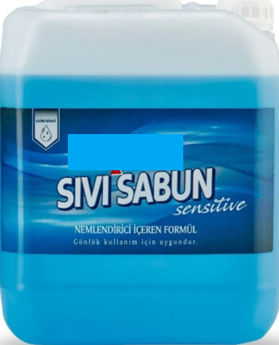
2 | Çift Kovalı Temizlik Arabası (Mop ve sap dahil) / Double Bucket Cleaning Trolley (Including mop and handle) | *Çift kovalı(her kova 20 Lt hazneli) temizlik arabası krom gövdeli ve presli olacaktır. Temizlik arabasının 360 derece dönebilen tekerlekleri buluncak ve araba uzun süre kullanıma dayanıklı olacaktır. Temizlik arabasına metal saplı, 120 cm uzunluğundaki sap ve 350 gr ağırlığındaki, beyaz mop dahil olacaktır.  * The cleaning trolley with double buckets (each bucket has a 20-liter reservoir) will have a chrome body and a press. The cleaning cart will have 360-degree rotating wheels and the cart will be durable for long-term use. The cleaning trolley will include a white mop with a metal handle, a 120 cm long handle and a weight of 350 g. | 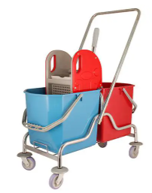  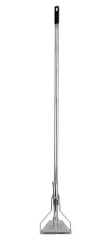  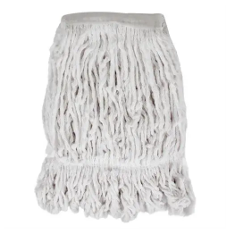
3 | Yüzey Temizleyici - 5 lt / Surcafe Cleaner 5 Lt | *Her türlü yüzey temizliği için uygun, çamaşır suyu katkılı, 5 litrelik plastik konteynerde, kokulu  *Suitable for cleaning all kinds of surfaces, bleach added, in a 5 liter plastic container, scented. | 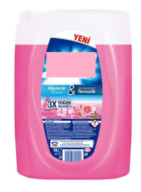
4 | Fırça / Brush | *21.5 cm yumuşak yer fırçası ve 120 cm ahşap sap  *21.5 cm soft floor brush and 120 cm wooden handle |   
5 | Çekpas / Squeegee | *Zeminde kir, su, toz bırakmayan, 75 cm genişliğinde, sert zeminde kulllanıma dayanıklı çekpas ve 120 cm ahşap sap  *75 cm wide squeegee that does not leave dirt, water or dust on the floor, resistant to use on hard floors and 120 cm wooden handle | 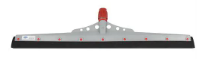  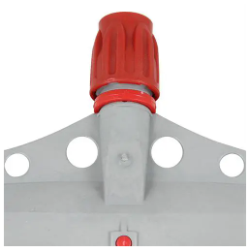
6 | Silme bezi 4'lü paket / Wiping cloth 4 pack | *Çok amaçlı, yıkanabilir, mikrofiber, iz bırakmayan, 40*40 cm, 4'lü paket silme bezi  *Multi-purpose, washable, microfiber, non-marking, 40*40 cm, pack of 4 wiping cloth | 
7 | Çöp poşeti Jumbo boy-koli(20 adet) / Garbage bag Jumbo size-box (20 pieces) | * 80*110 cm ebatlarında, ekstra dayanıklı, rülo şeklinde, her pakette 10 adet çöp poşeti bulunan, siyah renkli çöp poşeti, her kolide 20 paket bulunan  *80*110 cm size, extra durable, roll shaped, black colored garbage bag with 10 garbage bags in each package, 20 packages in each box | 
8 | Çöp poşeti Orta boy-koli(50 adet) / Garbage bag Medium size-box (50 pieces) | * 55*60 cm ebatlarında, ekstra dayanıklı, rülo şeklinde, her pakette 15 adet çöp poşeti bulunan, sarı yada mavi renkli  * 55*60 cm in size, extra durable, roll-shaped, with 15 garbage bags in each package, yellow or blue in color. | 
9 | Plastik çöp kovası 25-30 lt / Plastic garbage bin 25-30 lt | *25 veya 30 lt hacme sahip, plastik, kapaklı, ekstra dayanıklı çöp kovası  *Extra durable plastic waste bin with lid, 25 or 30 lt capacity | 
10 | Tuvalet Kağıdı 32'li 3 katlı / Toilet Paper 32 packs 3 ply | *Tuvalet tıkamayan, 3 katlı, 32 rülo barındıran, beyaz, %100 selülozdan üretilmiş, tuvalet kağıdı  *Non-clogging, 3-layer, 32 rolls, white, made of 100% cellulose, toilet paper | 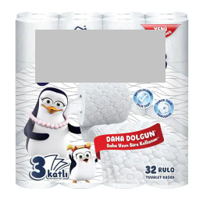
11 | Kağıt havlu dispanseri plastik / paper towel dispenser plastic | *Z katlama havlu kapasitesi 200 adet olan(havlu ebatı:22*8 cm), mavi ve beyaz renkli, plastik dispenser  *Z-fold towel capacity 200 pieces (towel size: 22*8 cm), blue and white, plastic dispenser | 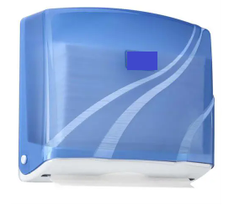
12 | Katlanabilir kağıt havlu-12li koli /  Foldable paper towels - box of 12 | *Kolisinde 12 paket bulunan, 2 katlı, 200 yapraklı. 21*22.5 cm ebatlarında, yüksek emiş gücüne sahip, Z katlamalı kağıt havlu  *It has 12 packages in its box, 2 layers, 200 sheets. 21*22.5 cm size, high absorbency, Z-fold paper towel | 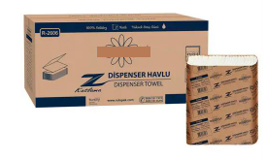

- Materials should meet the specifications, and if necessary, samples and measurements should be provided in advance in exceptional circumstances.
- Supplier must share a catalogue containing all the items specified above.
- The price quotation should include transportation, assembly, and relocation services to the designated warehouse or destination.
- Save the Children does not commit to purchasing all products and retains the right to request items based on needs and quantities required.

PACKAGING AND SHIPPING PRINCIPLES
All requested materials will be provided in closed and the original boxes. The information and quantities of the products inside will be written on the boxes.
The supplier company is responsible for any damage, loss and collateral damage that may occur during shipping and delivery, and for the elimination of damages that have occurred. In similar cases, Save the Children Turkey Representative has the freedom not to accept the products unless the deficiencies are corrected.
The products will be delivered to Save the Children’s designated locations in Gaziantep/Adıyaman.
The supplier will be responsible of delivering all required products as per DDP incoterm. All expenses including delivery, loading, offloading must be included in the price for Gaziantep.

PRACTICE PRINCIPLES AND CONTROL
- Payments will be made over the performance of the unit services specified in the tender annex. The Contractor accepts and undertakes that he/she cannot demand price difference for any service.

- In this agreement, no advance payment or interim progress payment will be made, and payment may be requested after the delivery of the works is completed.

- The completion of the work subject to the order will be subject to the approval of the SCI officer. The order will not be considered completed until the revisions that may be requested at the end of the work are completed, and the payments will be made when the revision etc. is followed by the progress payment.

PART 3 – BIDDER RESPONSE DOCUMENT

- INTRODUCTION

This document MUST BE USED by Bidders wishing to submit a bid. It is linked into 5 sections detailed below:

- Section 1 – Essential Criteria
- Section 2 – Capability, Sustainability & Innovation Questions
- Section 3 – Commercial Questions
- Section 4 – Bidder Submission Checklist

The Bidder is required to sign a copy of the Check list in Section 4 as part of their submission.

- INSTRUCTIONS

Within each section there are instructions providing guidance to the bidder on what information is required. This guidance details the MINIMUM requirements expected by SCI.

For your bid response please complete all the sections in this Part 3 below.

Where you believe there is an alternative specification or solution to the requirements in Part 2 above you may submit an additional bid response. For avoidance of doubt this will require you to submit two (2) separate bid response documents. Both bids shall be evaluated following the same process as outlined in Part 1 above.

If a Bidder wishes to add further information, this is acceptable, but the additional information should be limited to only items that are relevant to the tender.

- For the avoidance of doubt, bidders are required to complete all items within the Bidder Response Document unless clear instruction is provided otherwise.
- If a Bidder does not complete the entire Bidder Response document, their submission may be declared void.
- If a Bidder is unable to complete any element of the Bidder Response Document, they should contact Save the Children through the using the contact details provided for guidance.

By submitting a response, the bidder confirms that all information provided can be relied upon for validity and accuracy.

SECTION 1 - ESSENTIAL CRITERIA
INSTRUCTIONS – Bidders are required to complete all sections of the below table.
Item | Question | Bidder Response
1 | Bidder accepts Save the Children’s ‘Terms and Conditions of Purchase’ and that any business awarded to the bidder will be completed under the Terms and Conditions included in Section 4 of this pack. | Yes / No | Comments / Attachments
2 | The Bidder and its staff (and any sub-contractors used) agree to comply with: i) SCI’s Supplier Sustainability Policy [set out under Section 4 of this document] throughout this process and during the term of any future contract awarded. | Yes / No | Comments
3 | The bidder confirms they are not a prohibited party under applicable sanctions laws or anti-terrorism laws or provide goods under sanction by the United States of America or the European Union and accepts that SCI will undertake independent checks to validate this. | Yes / No | Comments
4 | The Bidder confirms it is fully qualified, licenses and registered to trade with Save the Children (including compliance with all relevant local Country legislation).  This includes the Bidder submitting the following requirements (where applicable):  - Legitimate business address  - Tax registration number & certificate  - Business registration certificate  - Trading license | Yes / No | Comments
 |  | Requirement | Bidder Response / Attachments
 |  | Legitimate Business Address
 |  | Tax Registration Number & Certificate
 |  | Business Registration Certificate
 |  | Trading License
5 | A statement (signed/stamped) that confirms submitted unit prices (US Dollar) are going to be valid for at least 120 days. | Yes / No | Comments / Attachments
6 | Payment within 30 calendar days after the delivery of the requested items. | Yes / No | Comments / Attachments
7 | The bidder must submit sample to above address. | Yes / No | Comments / Attachments

SECTION 2 – CAPABILITY, SUSTAINABILITY, & INNOVATION QUESTIONS
Instructions – Bidders are required to complete all sections of the below table.
Item | Question | Bidder Response
1 | Delivery lead time (20%)  Lead time to deliver the requested items upon receiving an official order form SCI.  Please mention your response in number of calendar days  20 x (Lowest Lead Time / Given Lead Time) | Bidder Response | Attachment(s)
2 | Quality and technicality of the offered items (please share samples to above address. (20%) | Bidder Response | Comments
3 | The bidder has a legal establishment or a company in Gaziantep, Adıyaman or Kahramanmaraş or Hatay thus reducing the carbon footprint and developing the local economy after the earthquake. (10%) | Bidder Response | Comments

SECTION 3 – COMMERCIAL QUESTIONS
Nr | DESCRIPTION OF GOODS | UNIT | QUANTITY |  | VAT RATE | UNIT PRICE VAT INCLUDED | TOTAL PRICE VAT INCLUDED
1 | Liquid soap 20 Lt | piece | 1800
2 | Double Bucket Cleaning Trolley (Including mop and handle) | piece | 120
3 | Surcafe Cleaner 5 Lt | piece | 240
4 | Brush | piece | 240
5 | Squeegee | piece | 240
6 | Wiping cloth 4 pack | piece | 600
7 | Garbage bag Jumbo size-box (20 pieces) | box | 180
8 | Garbage bag medium size-box (50 pieces) | box | 300
9 | Plastic garbage bin 25-30 lt | piece | 240
10 | Toilet Paper 32 packs 3 ply | piece | 1800
11 | Paper towel dispenser plastic | piece | 240
12 | Foldable paper towels - box of 12 | box | 1800
13 | Delivery Cost to Adıyaman (city center and villages) | transfer | 1
14 | Delivery Cost to Kahramanmaraş (city center and villages) | transfer | 1
Total Price VAT Included
 | Please indicate your price validity period here, must be at least end of 2024 |  |  | ……. Days

SECTION 4 – BIDDER SUBMISSION CHECKLIST

We, the Bidder, hereby confirm we have completed all sections of the Bidder Response Document:
No | Section |  |  | Please Tick
1. | Section 1 – Essential Criteria
2. | Section 2 – Capability, Sustainability & Innovation Questions
3. | Section 3 – Commercial Questions
We, the Bidder, confirm we have uploaded all of the required information and supporting evidence:
Section |  | Required Document / Evidence |  |  |  | Please Tick
Essential Criteria Evidence |  | Proof of legitimate business address
 |  | Copy of tax registration number & certificate
 |  | Copy of business registration certificate
Capability Criteria Evidence |  | Completed Bidder Response Document
 |  | Supporting Financial Documents
Commercial Criteria Evidence |  | Completed Bidder Response Document
We, the Bidder, hereby confirm we compliance with the following policies and requirements:
Policy |  |  | Policy / Document |  | Signature
Terms & Conditions of Bidding
Terms & Conditions of Purchase
Supplier Sustainability Policy  and the included mandatory policies |  |  | Click Here to Access

We confirm that Save the Children may in its consideration of our offer, and subsequently, rely on the statements made herein.
Signature: | …………………………………………………..
Name: | …………………………………………………..
Title: | …………………………………………………..
Company: | …………………………………………………..
Date: | …………………………………………………..

