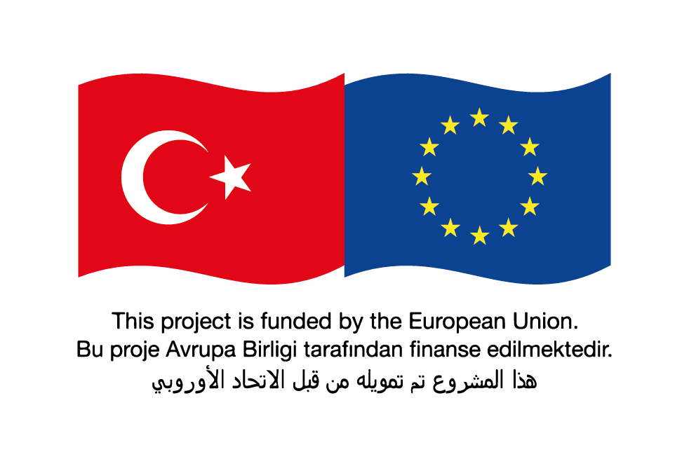

Request for Bids

Small Works

(One-Envelope Bidding Process)

**Country:** TÜRKİYE

**Name of Project:** Municipal Services Project-I

**Contract Title:** Construction of Gaziantep Yamaçtepe Sewerage Network Line

**Loan No./Credit No./ Grant No.:** CTR 1075 01 K

**RFB Reference No.:** AFD-GASKI W2_RB

1. In the capacity of Financial Support Programe for Refugeesin Turkey (FRIT 2) funded by EU and delegated to French Development Agency ( “AFD”), İLBANK supplied fundingto meet the cost of **Municipal Services Project –I.** ILBANK intends to apply part of the proceeds toward payments under the contract for the **Construction of Gaziantep Yamaçtepe Sewerage Network Line**
2. Gaziantep Water and Sewerage Administration (GASKİ)now invites sealed Bids from eligible Bidders for the construction of below items in Gaziantep whose contract duration will be 540 calendar days for construction and 365 calendar days for defects Liability Period.

|  |  |  |
| --- | --- | --- |
| **SEWERAGE NETWORK** |  |  |
| **Description** | **Unit** | **Quantity** |
| Laying of Ø 300 mm Concrete pipe with rubber joint | Meter | 39.698,00 |
| Laying of Ø 400 mm Concrete pipe with rubber joint | Meter | 2.155,00 |
| Laying of Ø 600 mm Concrete pipe with rubber joint | Meter | 1.729,00 |
| Laying of Ø 800 mm Concrete pipe with rubber joint | Meter | 207,00 |
| Installation of Prefabricated manhole with joint | Piece | 1.018,00 |
| Pipe jacking under highway with Ø1000 mm (1016,0 mm, E=8,73 mm) steel Pipe, inside with Ø600 mm Corrugated Sn8 Pipe | Meter | 70,00 |
| Pipe jacking under highway with Ø1400 mm (1422,0 mm, E=12,70 mm) steel Pipe, inside with Ø800 mm corrugated Sn8 Pipe | Meter | 91,00 |
| By-pass with Ø 600 mm Concrete pipe with rubber joint within concrete jacket | Meter | 52,00 |
| Manhole type Pump TM3 | Piece | 1,00 |
| Laying of Ø140 mm Pe 100 10 Atm. Pressure pipeline | Meter | 720,00 |
| Preparation of revised Sewerage Network Design of the existing design | Meter | 44.722,00 |
| Cast-in-Situ Manhole Using Steel Shoring (Trench Filling with Crushed Stone) | Piece | 1,00 |

1. Bidding will be conducted through international competitive procurement using a Request for Bids (RFB) as specified in the AFD’s “Procurement Guidelines for AFD-Financed Contracts in Foreign Countries” *October 2019* (“Procurement Regulations”), and is open to all Bidders as defined in the Procurement Regulations.

Interested eligible Bidders may obtain further information from *Gaziantep Water and Sewerage Administration (GASKİ),* Mr. ***Murat NOYAN*** ([**murat.noyan@gaski.gov.tr**](mailto:murat.noyan@gaski.gov.tr)**)** and inspect the bidding document during office hours *09:00 to 17:00 hours* at the address given below*.*

1. The bidding document in *Turkish* may be purchased by interested eligible Bidders upon the submission of a written application to the address below and upon payment of a nonrefundable fee of *5.000 TL*. The method of payment will be *direct deposit to bank account number* ***TR 410001500158007290404647*** *mentioning the payment is for AFD GASKI W2_RB.*The bidding document will be sent via courier, hand delivery or by *e-mail.*
2. Bids must be delivered to the address below on or before ***14:00*** *and* ***05/05/2025.*** Electronic Bidding will *will not* be permitted. Late Bids will be rejected. Bids will be publicly opened in the presence of the Bidders’ designated representatives and anyone who chooses to attend at the address below on ***14:30*** *and* ***05/05/2025.***
3. All Bids must be accompanied by a *“Bid Security”* of *150.000 EUR or equivalent[1]*
4. The addresses referred to above are:

**Place for obtaining further information regarding the bid documents, requesting clarifications and submitting bids:**

Gaziantep Water and Sewerage Administration

For the attention of: *Murat NOYAN*

Address: Değirmiçem Mah. Kıbrıs Cad. No:1/A Şehitkâmil

Floor/ Room Number: İhale Servisi

City: Gaziantep

Post Code: 27090

Country: Türkiye

Telephone: +90 [342 211 13 00](tel:+903422111300) Internal: 3232

Fax no: +90 [342 231 88 33](tel:+903422306436)

E-mail address: [murat.noyan@gaski.gov.tr](mailto:murat.noyan@gaski.gov.tr)

**Place for opening of bids:**

Address: Değirmiçem Mah. Kıbrıs Cad. No:1/A Şehitkâmil

Floor/ Room Number: İhale Servisi

City: Gaziantep

Post Code: 27090

Country: Türkiye

1. Please see Bidding document, Section II Bid Data Sheet (BDS), ITB 19.1.